**LAB ASSIGNMENT 3**

**OPERATING SYSTEMS**

Give shell scripts for following:

1. To find Largest of Three Numbers

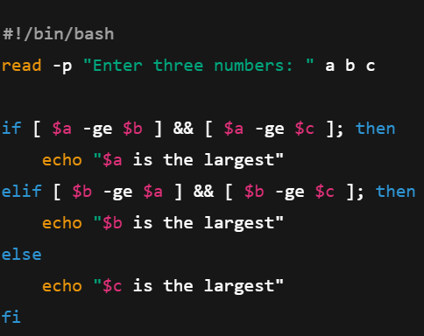

1. To find a year is leap year or not.

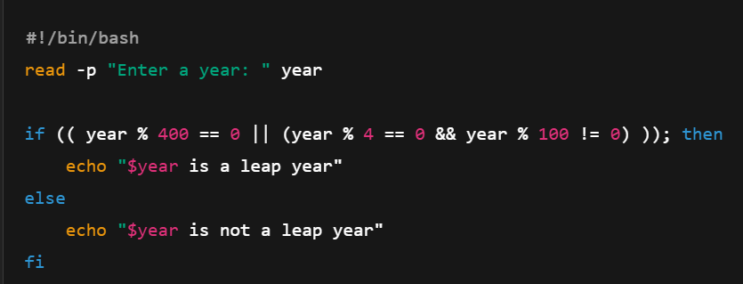

1. To input angles of a triangle and find out whether it is valid triangle or not

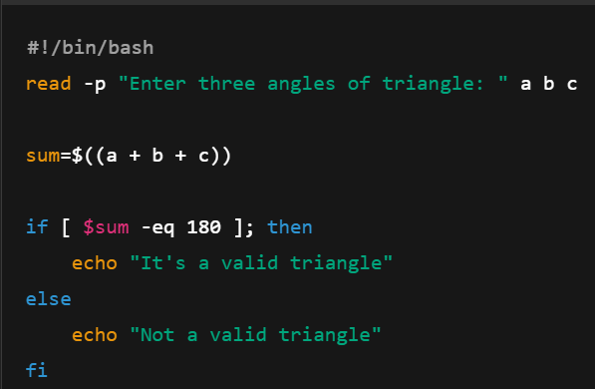

1. To check whether a character is alphabet, digit or special character.

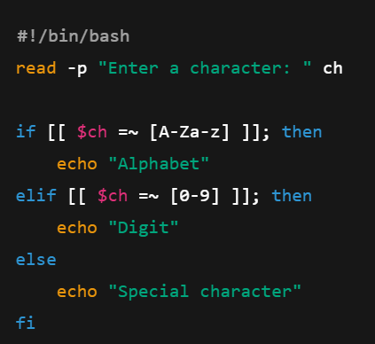

1. To calculate profit or loss

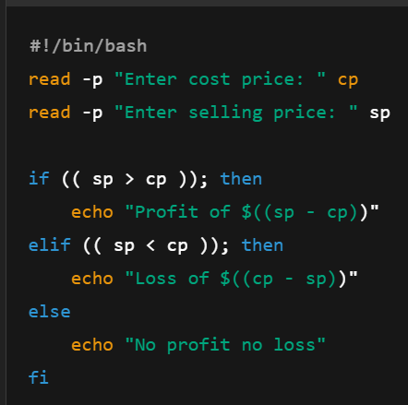

1. To print all even and odd number from 1 to 10

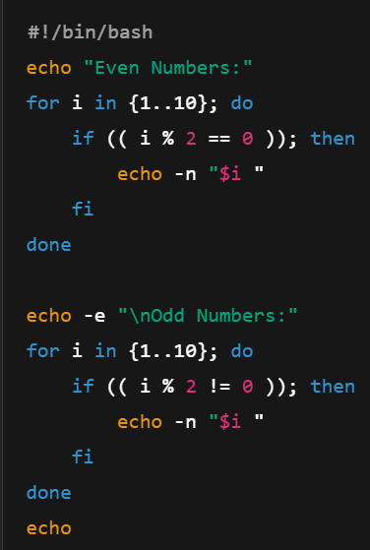

1. To print table of a given number

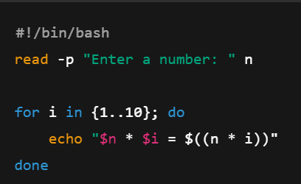

1. To find factorial of a given integer

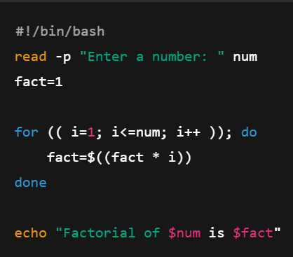

1. To print sum of all even numbers from 1 to 10.

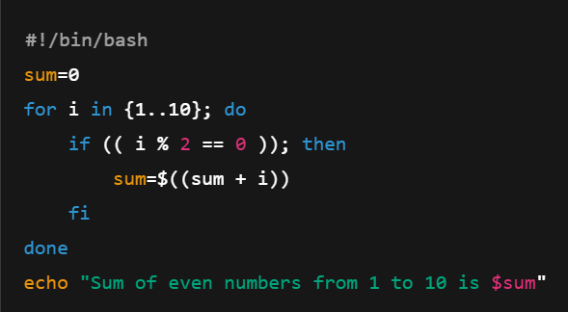

1. To print sum of digit of any number.

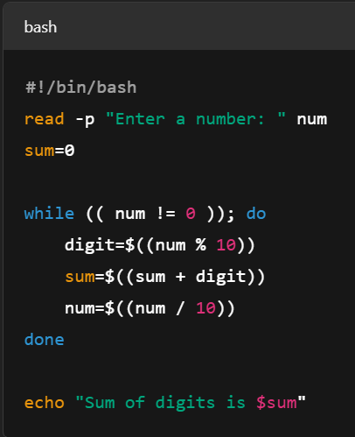

11. To make a basic calculator which performs addition, subtraction, Multiplication,

Division

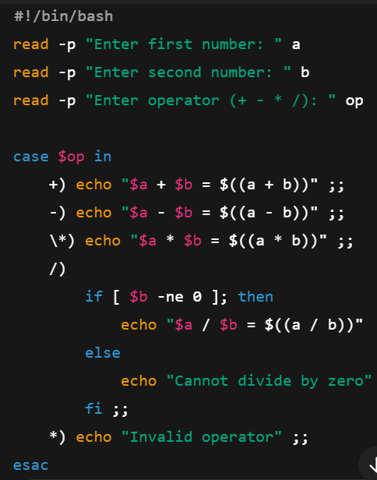

1. To print days of a week.

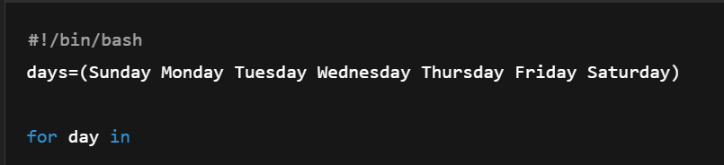

1. To print starting 4 months having 31 days.

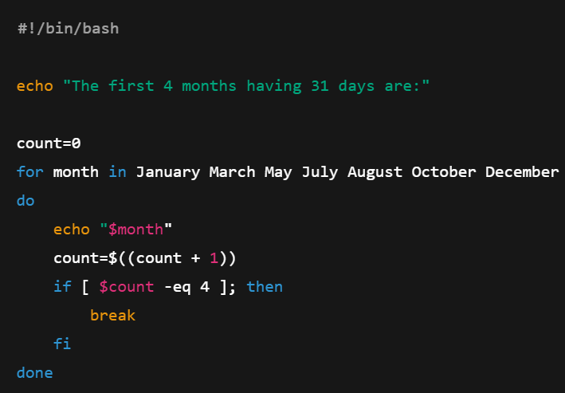

14. Using functions,

a. To find given number is Amstrong number or not

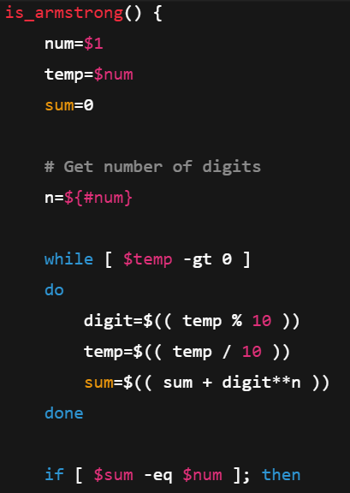

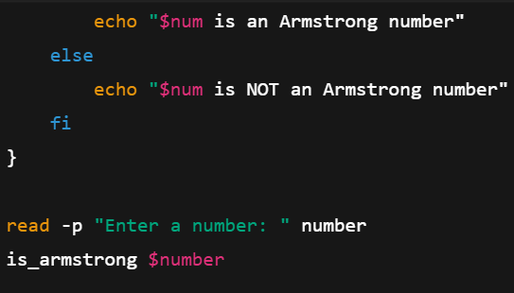

b. To find whether a number is palindrome or not

